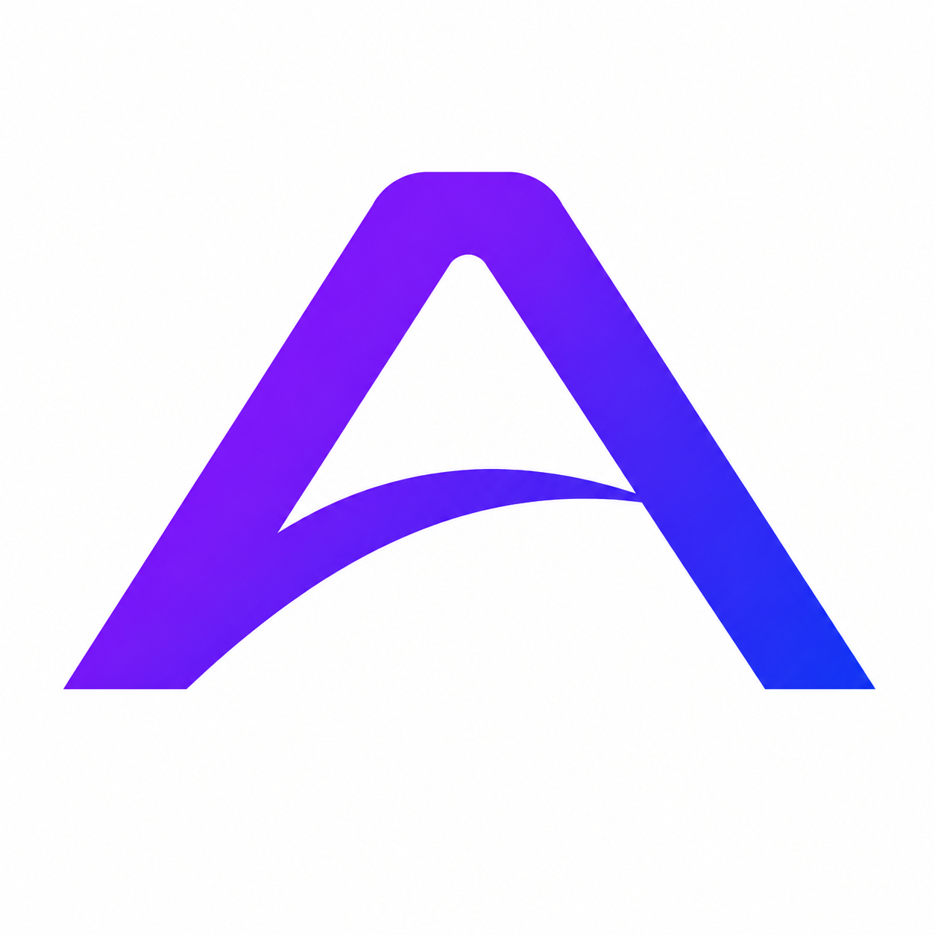
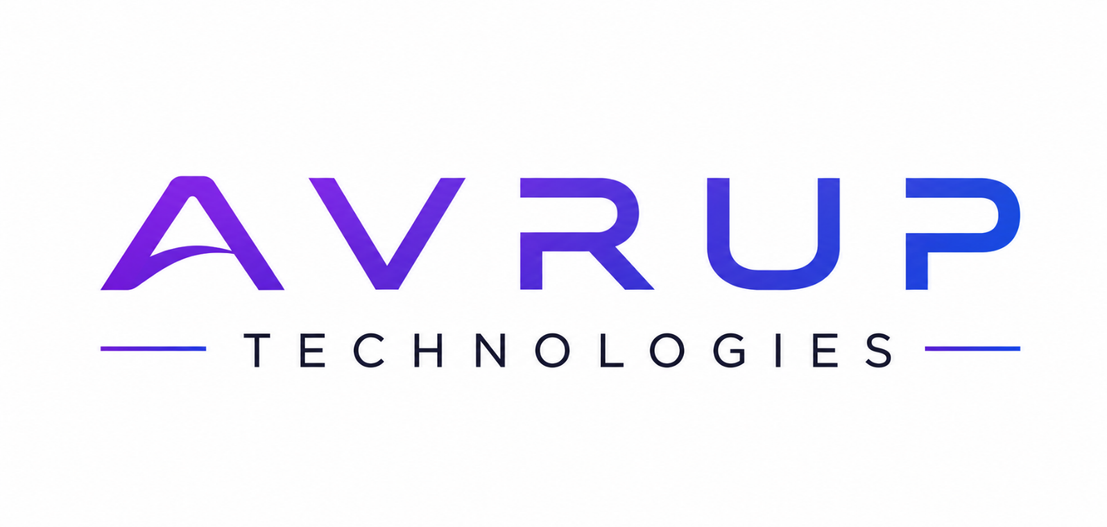
WEBSITE DEVELOPMENT & DIGITAL SOLUTIONS PROPOSAL

WHO WE ARE:
Avrup Technologies is a modern digital solutions company focused on delivering innovative, scalable, and visually impactful digital experiences. We help businesses establish a powerful online presence through:
- Website Development
- Branding
- UI/UX Design
- Social Media Marketing
- SEO & Digital Growth
- Custom Digital Solutions
Our goal is to combine creativity with technology to help brands grow faster in the digital world.

WHY CHOOSE AVRUP TECHNOLOGIES?
✅ Modern & Premium Designs
✅ Mobile Responsive Websites
✅ Affordable Pricing
✅ Fast Delivery
✅ SEO-Friendly Development
✅ Professional Branding
✅ Ongoing Support
✅ Client-Focused Approach

OUR SERVICES
- Website Development
- Business Websites & Landing Pages
- Portfolio Websites

- E-Commerce Websites
- WordPress Websites
- Custom Web Applications

- Branding & Graphic Design
- Logo Design
- Social Media Creatives
- Brand Identity
- Posters & Banners

- Corporate Designs

- Digital Marketing
- Social Media Management
- Instagram Growth
- LinkedIn Branding
- Performance Marketing
- Audience Engagement
- Marketing Campaigns

- SEO & Optimization
- Website Optimization
- SEO Setup
- Google Visibility
- Speed Optimization
- Performance Improvements

WEBSITE PACKAGES
STARTER PACKAGE
(Perfect for startups and personal brands.)
Includes:

• 1–5 Page Website
• Mobile Responsive Design
• Modern UI Layout
• Basic SEO Setup
• Contact Form Integration
• Social Media Integration
• WhatsApp Integration
• Fast Loading Website
• Basic Security Setup
• 1 Month Free Maintenance
Market Price:
₹14,999–₹19,999
Your Price:
₹9,999+

BUSINESS PREMIUM PACKAGE
(Best for growing businesses.)
Includes:
• Professional Business Website
• WordPress Development
• Responsive & Modern Design
• Admin Panel Access
• SEO-Friendly Structure
• WhatsApp Integration
• Contact & Inquiry Forms
• Social Media Integration
• Fast Loading Optimization
• Google Map Integration
• Technical Support
• 1 Year Maintenance Support
Market Price:
₹29,999–₹49,000
Your Price:
₹24,999

BUSINESS PREMIUM PACKAGE
(Advanced business solutions for scalable growth.)
Includes:

• Fully Custom Business Website
• Advanced UI/UX Design
• Premium WordPress Development
• Custom Pages & Features
• Mobile Responsive Layout
• Admin Dashboard Access
• Advanced SEO Optimization
• Business Email Setup
• Payment Gateway Integration
• WhatsApp & CRM Integration
• Google Map & API Integrations
• High-Speed Performance Optimization
• Enhanced Security Configuration
• Social Media Integration
• Technical Support & Assistance
• 24/7 Priority Support
• 1 Year Premium Maintenance
Market Price:
₹79,000–₹1,99,999
Your Price:
₹59,999

SOCIAL MEDIA & MARKETING PACKAGES
BASIC SOCIAL MEDIA PACKAGE
₹7,999/-
Includes:
- 12 Monthly Posts

- Basic Branding
- Captions & Hashtags
- Instagram, Facebook & LinkedIn, Management

ADVANCED MARKETING PACKAGE
₹14,999/-
Includes:
- 16 Monthly Posts
- Content Strategy
- Full Social Media Management
- Ad Campaign Support
- LinkedIn Branding
- Audience Engagement
- Analytics Reports

BRANDING PACKAGE (Personalization)
₹9,999/-
Includes:
- Professional Logo Design
- Brand Color Palette
- Typography Selection
- Social Media Kit
- Brand Guidelines

OUR WORK PROCESS
Step 1 — Requirement Discussion
Understanding business goals and project expectations.
Step 2 — Strategy & Planning
Creating roadmap, design direction, and structure.
Step 3 — Design & Development
Building modern, responsive, and scalable solutions.
Step 4 — Testing & Optimization
Ensuring quality, performance, and responsiveness.
Step 5 — Delivery & Support
Project launch with ongoing support and maintenance.

WHAT MAKES US DIFFERENT?
✔ Affordable Pricing Compared to Market
✔ Modern & Creative UI/UX
✔ Personalized Client Support
✔ Startup-Friendly Solutions
✔ Scalable & Future-Ready Development
✔ Strong Branding Expertise

CLIENT BENEFITS
✅ Increased Online Presence
✅ Better Brand Visibility
✅ Professional Business Identity
✅ Higher Customer Trust
✅ Improved User Experience
✅ Faster Business Growth

CONTACT US

AVRUP TECHNOLOGIES
+91 9772056295

+91 9352699060

avruptechnologies@gmail.com

www.avrup-technologies.vercel.app


Let’s Build Something Exceptional Together.

